./

GENESIS - Learning Outcome & Mini-project Summary Report



|  |  |  |  |  |  |
| --- | --- | --- | --- | --- | --- |
| **Ver. Rel. No.** | **Release Date** | **Prepared. By** | **Reviewed By** | **To be Approved** | **Remarks/Revision Details** |
|  |  |  |  |  |  |
|  |  |  |  |  |  |
|  |  |  |  |  |  |
|  |  |  |  |  |  |
|  |  |  |  |  |  |

**Details**

Contents

Contents 3

Mini Project -1 Python programming (System Development life cycle) 4

1.1 Modules Used 4

1.2 Project title: Mini Calculator 4

1.3 Topic and Subtopics 4

1.4 Objectives & Requirements 4

1.4.1 High Level requirement analysis 4

1.4.1 High Level requirement analysis 5

1.5 Design 5

1.5.1 Use Case LLR Diagram 5

1.5.2 Object LLR Diagram 6

1.6 Test Plan 7

1.6.1 High Level Test Plan 7

1.6.2 Low Level Test Plan 7

1.7 Implementation Summary 8

1.8 Video Summary 9

1.9 Git Link 9

1.10 Git Dashboard 9

1.10.1 Badges 9

1.10.2 Git Inspector 9

1.10.3 Setup for Build 11

1.10.4 Outcome of the Build 11

1.10.5 Setup for Code Quality 12

1.10.6 Outcome of Code Quality 12

1.10.7 Setup for Unity Testing 13

1.10.8 Outcome of Unity Testing 13

1.11 Individual Contribution & Highlights 14

1.12 Summary 14

1.13 Challenges faced and how were they overcome 14

Miniproject -2 [Team] 15

Embedded C 15

Topic and Subtopics 15

Objectives 15

Requirements 15

Design 15

Test Plan 15

Implementation Summary 15

Git Link 15

Git Dashboard 15

Summary 15

Individual Contribution & Highlights 16

Summary 16

Challenges faced and how were they overcome 16

# Mini Project -1 Python Programming (System Development life cycle)

## 1.1 Modules Used

Modules used in this project are SDLC and C programming.

## 1.2 Project title: Mini Calculator

“Modules linked to the miniproject Ex – Linux, SDLC and C++ or SDLC and HTML etc”

## 1.3 Topic and Subtopics

The core steps of SDLC is being implemented.

• The features of Calculator are implemented.

• The testing has been done for each function.

Introduction about SDLC

C Programming

Code Analysis

PEP8

V Model

Agile Model

Git Hub

“Briefly list the core topics and subtopics being implemented and how”

## 1.4 Objectives:

To extract the data present in different spreadsheets in one excel file as required by the user.

## Requirements:

### 1.4.1 High Level requirement analysis

|  |  |  |  |
| --- | --- | --- | --- |
| Id | Requirements | Description | Status |
| HL1 | Searching Data | Search all data from 5 sheets when user defines the PS number to be searched. | Implemented |
| HL2 | writing to excel | Write all the data from different spreadsheet in one master sheet | Implemented |
| HL3 | extracting user defined data | Write required data in the excel file. | Implemented |
| HL4 | plotting the bar chart | plot the bar chart of the data present in the mastersheet. | Implemented |

### 

### 1.4.2 Low Level requirement analysis

|  |  |  |  |
| --- | --- | --- | --- |
| **id** | **Requirements** | **Description** | **Status** |
| LL1 | Search Parameters | The user defines the Name or PS Number or Email Id of the data to be searched | Implemented |
| LL2 | Searching Data in excel file in every sheet | The data to be searched is defined by the user. | Implemented |
| LL3 | writing the data into master sheet | Data defined by user has to be extracted from 5 different spreadsheets and put into one master sheet. | Implemented |
| LL4 | Plotting the bar chart | plot the bar chart of the data present in the master sheet considering rows and columns. | Implemented |

## 1.5 Design

### 1.5.1 Use Case LLR Diagram

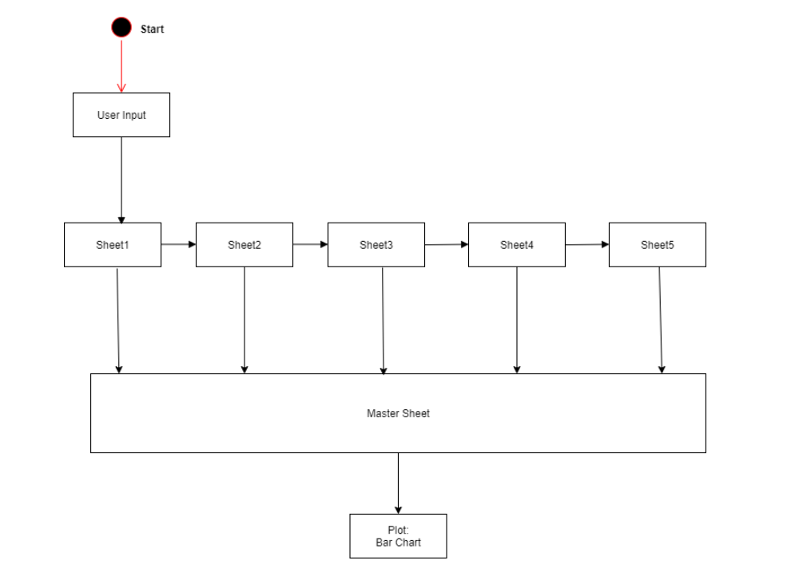

### 1.5.2 Object HLR Diagram

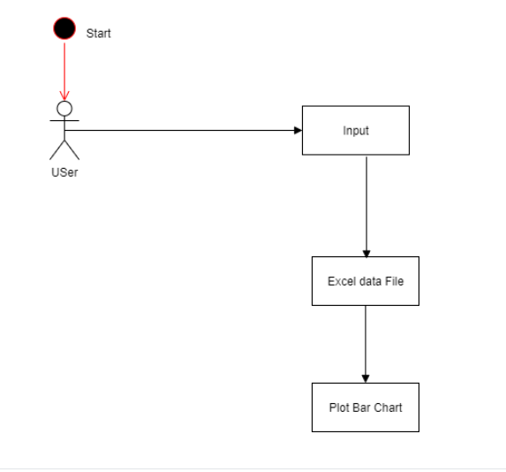

## 1.7 Implementation Summary

The aim of the project is to extract the data present in different spreadsheets in one excel file as required by the user. The excel sheet consists of 5 spreadsheets. The user defines the data that needs to be searched on the basis of Name, PS Number and Email ID. The python program then reads the data corresponding to the particular data from different spreadsheets of excel. It then creates a master sheet and adds the data from all the sheets to it. In the end, it will plot the bar graph from the data present in the master sheet.

## 1.8 Video Summary

“Please upload a short video on the repo for the walkthrough of the project (Team/Individual) less than 7min and less than 30MB File Size. Start is the Standard opening slide with title of miniproject + Team members followed by the walkthrough”

## 1.9 Git Link

<https://github.com/99003751/Python_Mini_Project.git>

## 1.10 Individual Contribution & Highlights

* Trigonometry and Logical feature is implemented.
* Test case for the same is implemented.
* High level and low-level test cases is implemented for the same.
* Issue raised and the issue was solved.
* 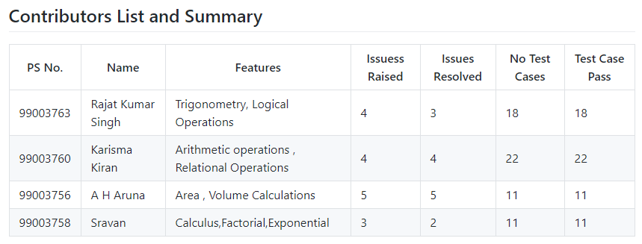Helped during the workflow's implementation of the project.

## 1.11 Summary

### 1.11.1 Outcomes:

Technical:

* Improved implementation of Python concepts.
* Practical implementation of SDLC lifecycle.
* Source code management. (GitHub )

Soft skills:

1. Project management

2. Conflict management.

## 1.12 Challenges faced and how were they overcome

* System issues(crashing and Interfacing).
* Differentiation of high level and low level.
* Committing to GitHub, pull and push in GitHub.
* Converting pictures & tables into readme file.

# 